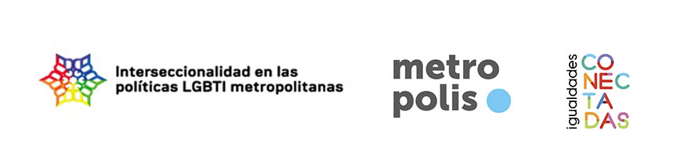
EXPERIENCES OF INTERSECTIONAL LGBTI POLICIES IN THE LOCAL SPHERE

To whom it may concern,
The intersectional perspective is an interesting proposal for local administrations because it serves to provide a more global and comprehensive response to the junctions between different axes of inequality such as gender, ethnicity, age, social class, disability, sexual orientation and gender identity. Despite its potential, there is still very little experience of its implementation from local administrations.
With a view to highlighting the local LGBTI policies that adopt an intersectional perspective, we are putting together a collection of experiences that falls under the convergence of two projects. The first is “Intersectionality in metropolitan LGBTI policies”, financed by the World Association of the Major Metropolises (Metropolis), with participation from the governments of the cities of Montevideo, Barcelona, Berlin, Buenos Aires, Mexico City and Medellin, and in collaboration with the University of Vic (UVic – UCC). The second is the project “Connected Equalities. Intersectionality in local public policies”, co-financed by the European Commission, driven by the Terrassa City Council and with participation from the UVic-UCC and CEPS Projectes Socials.
In particular, we are seeking experiences of local LGBTI policies that work on the intersection with other axes of inequality, for example:
- Diagnoses prior to the design of policies or assessment processes that take into account the situation some individuals or social groups are experiencing as a result of the intersection of different axes of inequality.
- Participation spaces or processes that include social actors from different axes.
- Work spaces in the local government sphere that work from an intersectional logic: fostering approaches to the problem that take into account the different axes of inequality and their convergences.
- Programmes and actions that make an explicit effort to include in the LGBTI group those groups that find themselves at the intersection between different axes.
- Community projects funded by the administration, which seek to work on the LGBTI subject matter from an intersectional perspective.
- Organisational changes that promote an intersectional approach (internal training, rotation of staff between different services, etc.).
An example would be a diagnosis about employment that takes into account how ethnicity, gender identity and age intersect; or an action against bullying that tackles jointly discriminations on the grounds of LGBTI, ethnicity and religious diversity.
To this end, we ask the staff of local governments to send us their experiences using the form below. By clicking on the following links you can access the same form in its on-line format in English and Spanish .
Should you have any doubts about the form or the projects, please contact us at the following email address: roser.sola@uvic.cat.
Yours sincerely,
Gerard Coll-Planas, Roser Solà-Morales and Miquel Missé
Line of studies in sexual diversity and gender
University of Vic –Central University of Catalonia

CONTACT *
The personal data provided will only be used to solve doubts or to expand on information related to the form. If the experience is selected for publication as part of the research project, we will contact you beforehand to check the data that need to appear.
Personal data will be processed in accordance with the principle of personal data protection established by Spanish and European legislation. For more information: https://www.uvic.cat/en/legal-notice-and-data-protection-0
Name of contact person or reference
Local government
Department, area or section of the local government
E-mail of the contact person | Telephone
I would like to receive regular updates on the projects (activities, publications, events, etc.)
Yes No
* Should one same person present more than one experience, they only need to fill out the contact details on the first form, indicating the reference person on the following forms.

BASIC INFORMATION ABOUT THE EXPERIENCE
The information provided may be published as part of the research project. In order to unify the format and style of the experiences, we reserve the right to edit the information. Prior to publication, the reference person will be contacted for approval.
Title of the experience
Web link to the experience
Axes intersecting with sexual and gender diversity
Migration / origin / refugee
Gender / male-female equality
Functional diversity / disability
Age / life cycles / infancy / adolescence / youth / elderly people
Religious diversity and differing beliefs
Interculturality / ethnic and racial diversity / racism
Social class / socio-economic inequalities
Other (please specify):
Subject areas (for example: sports, public space, health, education...)
Summary (8 lines approx.)
Main actors (for example: municipal departments, other public institutions, associations, individuals, businesses/consultancy companies…)
Start date | End date

DETAILED INFORMATION
Context in which the experience is taking place (problem detected, emergence of opportunity to act, etc.)
Objectives
Description of the action and implementation
Financing and resources
Results and impacts
Barriers and challenges
Lessons learned and transferability
References and external links
Photographs or any other graphic documentation can be sent to the email roser.sola@uvic.cat, indicating the title of the experience (for images, please include the authorship to be mentioned).

